# **SAT Preparation**

Course Syllabus

Mrs. Floyd, [afloyd@paulding.k12.ga.us](mailto:afloyd@paulding.k12.ga.us)

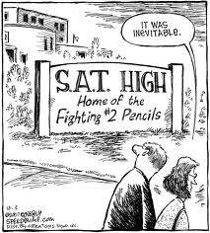**Course Description: The purpose of this course is to prepare you for the SAT!** What else is there to say? The SAT is a high-stakes test that helps determine whether students get into certain colleges. Moreover, the SAT is a test that is unlike the work completed in many English and math classes. As far as educational assessments go, it is *sui generis*—it’s unique. A unique assessment requires unique preparation, and that is what we will do in here.

Here in the English portion of SAT prep, we will complete practice questions in reading and writing, but that isn’t all. We will employ other strategies such as games and mnemonic devices to aid in mastering the fundamental principles of language and literacy that the SAT purports to test. Succeeding at the reading and writing portions of the SAT also require some reading and writing, so we’ll be doing that, too, but in a manner that will hopefully be different from what you encounter in your English classes. My hope is that this course will be a help, and not a burden, to your other coursework. I also hope that we can work together to relieve some of the anxiety that comes with a test like the SAT. Maybe this course will even be…fun?

**Text/Supplemental Materials:** Most of our test materials will be provided by Applerouth, The Princeton Review and USA Test Prep. Other reading selections may be used depending on circumstances. **You will also be required to read on your own on a regular basis.** Your independent reading selections will be up to you, provided they are (1) age-appropriate; (2) new to you; and (3) not required reading for another class. I will provide recommendations for books and periodicals at the beginning of the course and as the quarter progresses.

**Supplies: Students will need the following:**

1. One spiral notebook (for vocabulary, chronicling readings, and other notes)
2. Pens, no. 2 pencils, and paper
3. A **Gmail** address
4. One great attitude
5. One brain, new or used

**Grading Policies:**

Summative Assessment (projects, tests, writing assignments): 60%

Formative Assessment (class work, selected homework): 20%

Final Exam: 20%

Informal Work (participation, etc.): 0%--However, informal grades may still be recorded to document student participation.

**Online Grades:** Student grades and attendance can be accessed through the Paulding County School District website at www.paulding.k12.ga.us. Complete directions for the use of Infinite Campus are on the site. Attendance is up to date and may be viewed at any time.

**School Wide Mastery Learning Guidelines**

**In Case of Failure:** At EPHS, we believe in teaching for mastery. We understand that at times students struggle and need a little extra time and effort to master content material in order to be successful on assessments. With this in mind, we have developed the following guidelines for grade recovery throughout the semester.

Grade mastery opportunities will be offered on summative assessments in each class. The highest grade a student may earn on a grade mastery attempt is a **70%**.

Students may participate in recovery only if they have….

* Attempted the summative assessment (they turned it in).
* Failed the assessment (earned a grade below a 70%)
* Initiated the mastery process (It is the student’s responsibility to initiate the recovery attempt and complete all requirements including the reassessment within the two-week window.)
* Completed remediation task assigned by teacher (written reflection, tutoring, research, etc.) prior to reassessment.

Remediation task and reassessment must be completed within two weeks of receiving a failing summative grade. Students participating in mastery may be asked to complete a remediation task and/or reassessment before school, after school, or during class time at the discretion of the teacher.

**Class Expectations:**

1. Be on time and prepared. This lets me know you want to pass.

2. Respect yourselves and each other. Be aware of what we’re doing and make a positive contribution.

3. Respect your teacher. I’m here to help you fulfill your purpose in life.

4. Respect your environment. The custodians work very hard and could use your help keeping the place clean.

5. Follow directions the first time and DO NOT LIE. Wrongdoing complicates both your life and the lives of your peers. Integrity is easier in the long run.

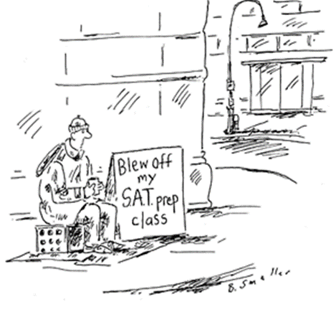

**Consequences:**

1. Conference with student.

2. Conference with student plus parent phone call.

3. Detention

4. Referral

**Plagiarism and Other Forms of Academic Dishonesty:** According to the Online Writing Lab (OWL) at Purdue University, plagiarism is “the uncredited use (both intentional and unintentional) of somebody else's words or ideas.” When you turn in your work, it is assumed that it is your own and that you do not use another writer’s words or ideas without giving appropriate credit. And yes, you CAN plagiarize yourself. **Plagiarism and other forms of academic dishonesty are serious offenses that will result in both a parent conference (phone or in person) and a zero for the assignment**. For help avoiding plagiarism, please see me or consult the Purdue OWL at <https://owl.purdue.edu/>.

**Attendance, Tardy, & Make-up Policies:** Please refer to the student handbook for board policies. Attendance records may be viewed at the PCSD Parent Portal at any time.

**PLEASE SIGN AND RETURN THE FOLLOWING**

I have read the above SAT Preparation syllabus and am aware of the academic and behavioral expectations of students in this course.

_______________________________ _________________________________

Student’s Name (printed) Parent/Guardian’s Name (printed)

_______________________________ _________________________________

Student’s Signature Parent/Guardian’s Signature

_________________ _________________

Date Date